**Name: Abdul Ahad**

**Email : aabdulahad142@gmail.com**

**Roll No: 31247**

**GitHub Link: Repository Link**

**FINAL PROJECT**

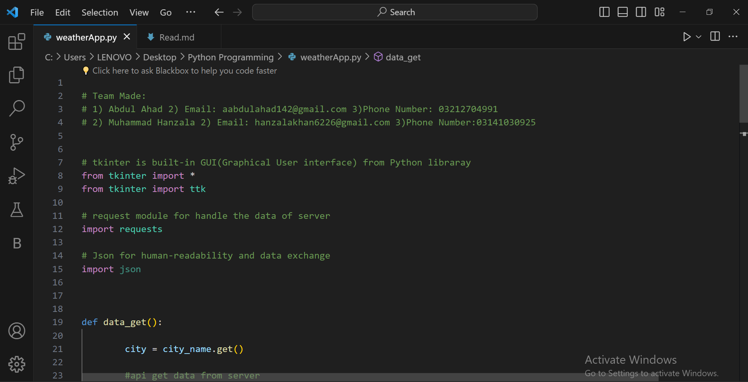

**Mosam Ka Haal**

**CODE**

**The weather forecasting application integrates Tkinter for a user-friendly interface, JSON for efficient data handling, and the request module for HTTP requests to a weather API. Through carefully crafted functions, tasks like fetching, parsing, and updating weather data are streamlined, ensuring a seamless user experience. Additionally, a configuration file securely stores sensitive information like API keys. This comprehensive approach enables users to easily input their location and receive accurate, real-time weather forecasts tailored to their needs. By combining these elements, the application aims to provide a convenient and intuitive solution for accessing reliable weather information, enhancing user satisfaction and utility in managing daily activities and planning ahead.**

**Project Description:**

**Project Name:**

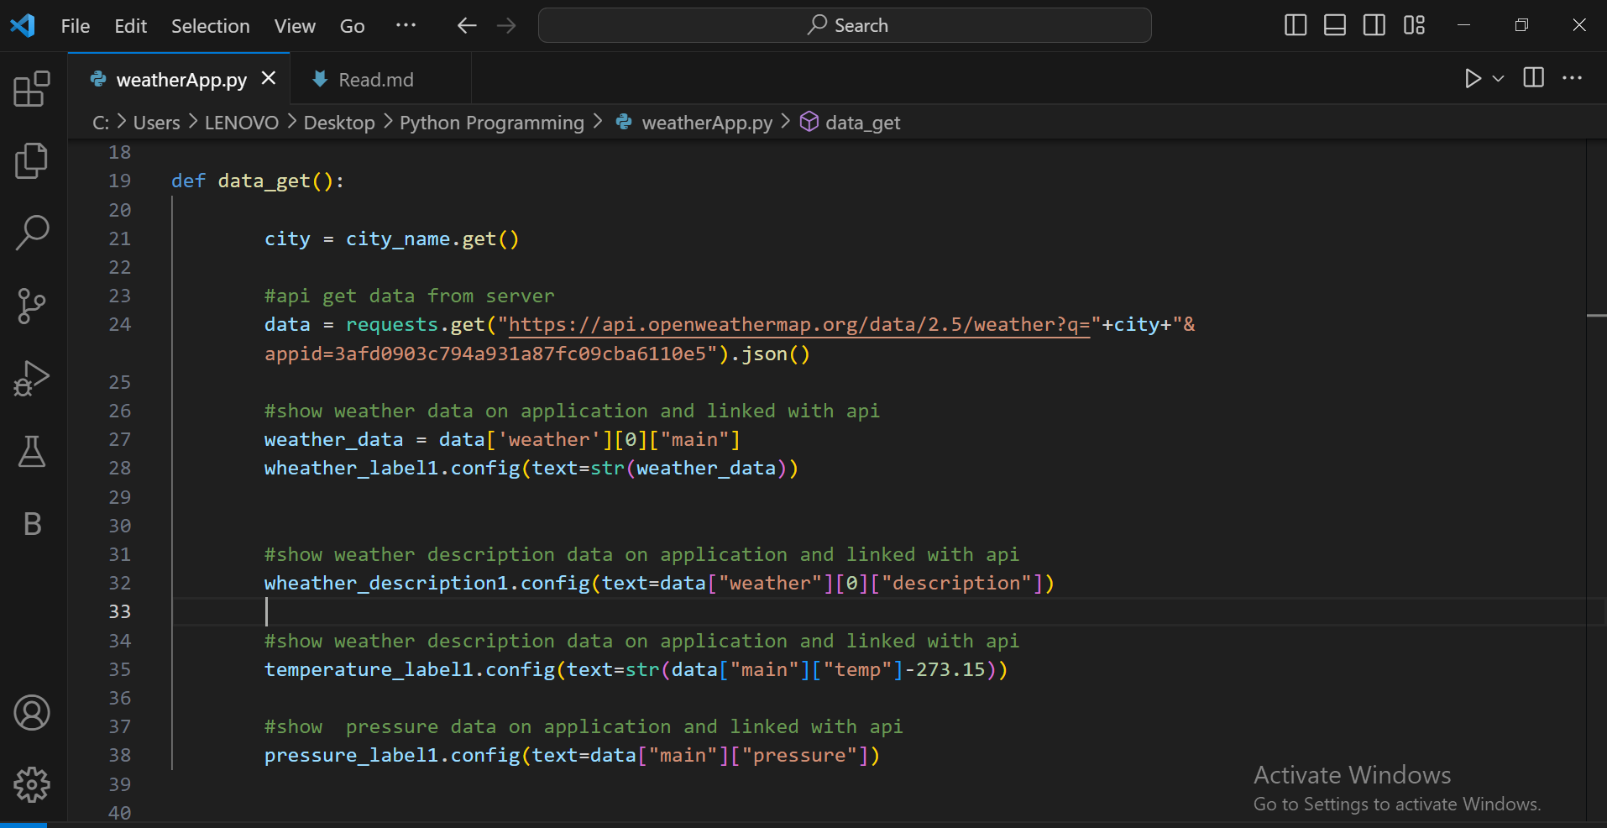

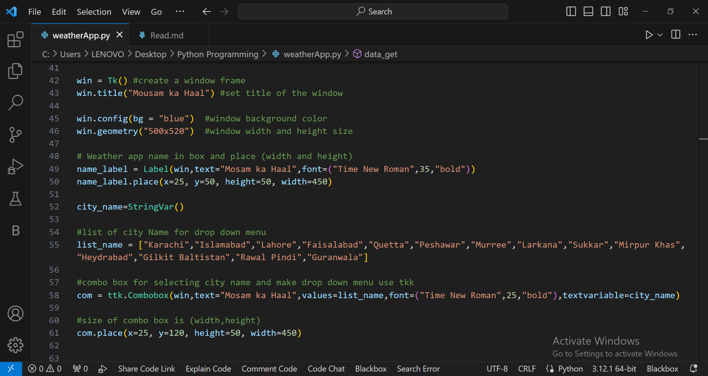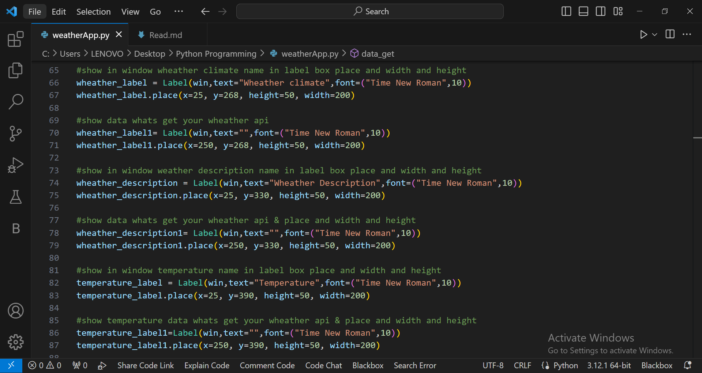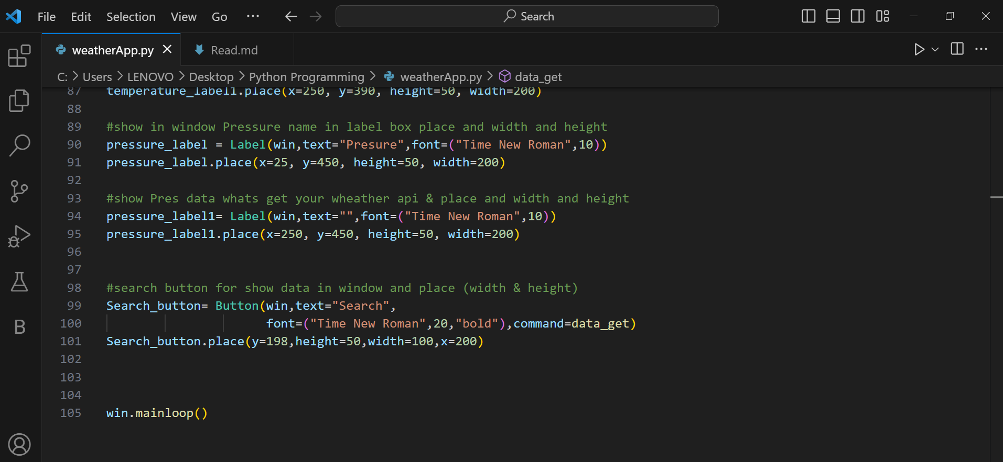

**OUT-PUT**

